This resource should be used as a guide to create your own assessment for remote employees. In order for employees to complete the assessment, they should be trained on how to evaluate different areas of health and safety in their home workspace.

Employee name:
Position title:
Home workstation address:
Supervisor:
Date completed:

Element Y N Comments
Fire Protection
Do you have a functioning smoke detector within the vicinity workspace?
Are there clear exits in your home workspace?
Do you have a functioning carbon monoxide detector in the home?
Element Y N Comments
Emergency Procedures
Do you have first aid supplies?
Do you know how to call 911 in the event of an emergency?
Do you have a check-in schedule with your supervisor?
Do you have an evacuation plan?

Element Y N Comments
Electrical Safety
Are electrical cords in good working condition (free of tears or exposed wires)?
Are the extension cords positioned out of the way so as not to be a tripping hazard?
Are extension cords being used in accordance with the manufacturer's label (i.e. not overloaded)?
Are the outlets grounded?
Is there surge protection for electrical equipment?
Element Y N Comments
House Keeping
Is your workspace clear of tripping hazards (electrical cords, loose carpeting and other objects)
Are materials neatly and safely piled?
Element Y N Comments
Ergonomics
Have you set up your workstation according to the ergonomic guidance provided by your employer?
Do you have the equipment necessary to meet the workstation guidelines on pg. 3?
Do you follow ergonomic best practices provided by your employer? (only work from your workstation, take regular breaks, stretch, etc.)

How to set up your workstation

Sitting at a desk

- Adjust the seat height so that your feet are supported by the floor or a footrest if your feet dangle.
- Your legs should be at a 90-degree angle.
- Your upper and lower back should be straight and supported. If your chair does not provide this support, use small cushions or pillows.
- Adjust your armrests so that your shoulders are relaxed.

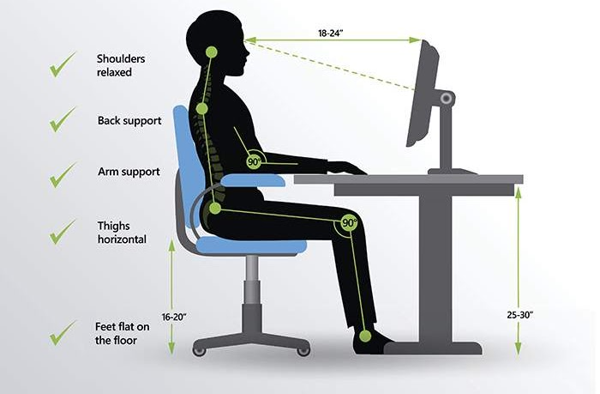

Standing at a desk

- Make sure that any cables, electrical access, storage of materials, and general layout do not make adjusting the desk difficult.
- Adjust the platform height so that it is at your standing elbow height position.
- Wear supportive footwear and shift your weight from leg to leg occasionally.

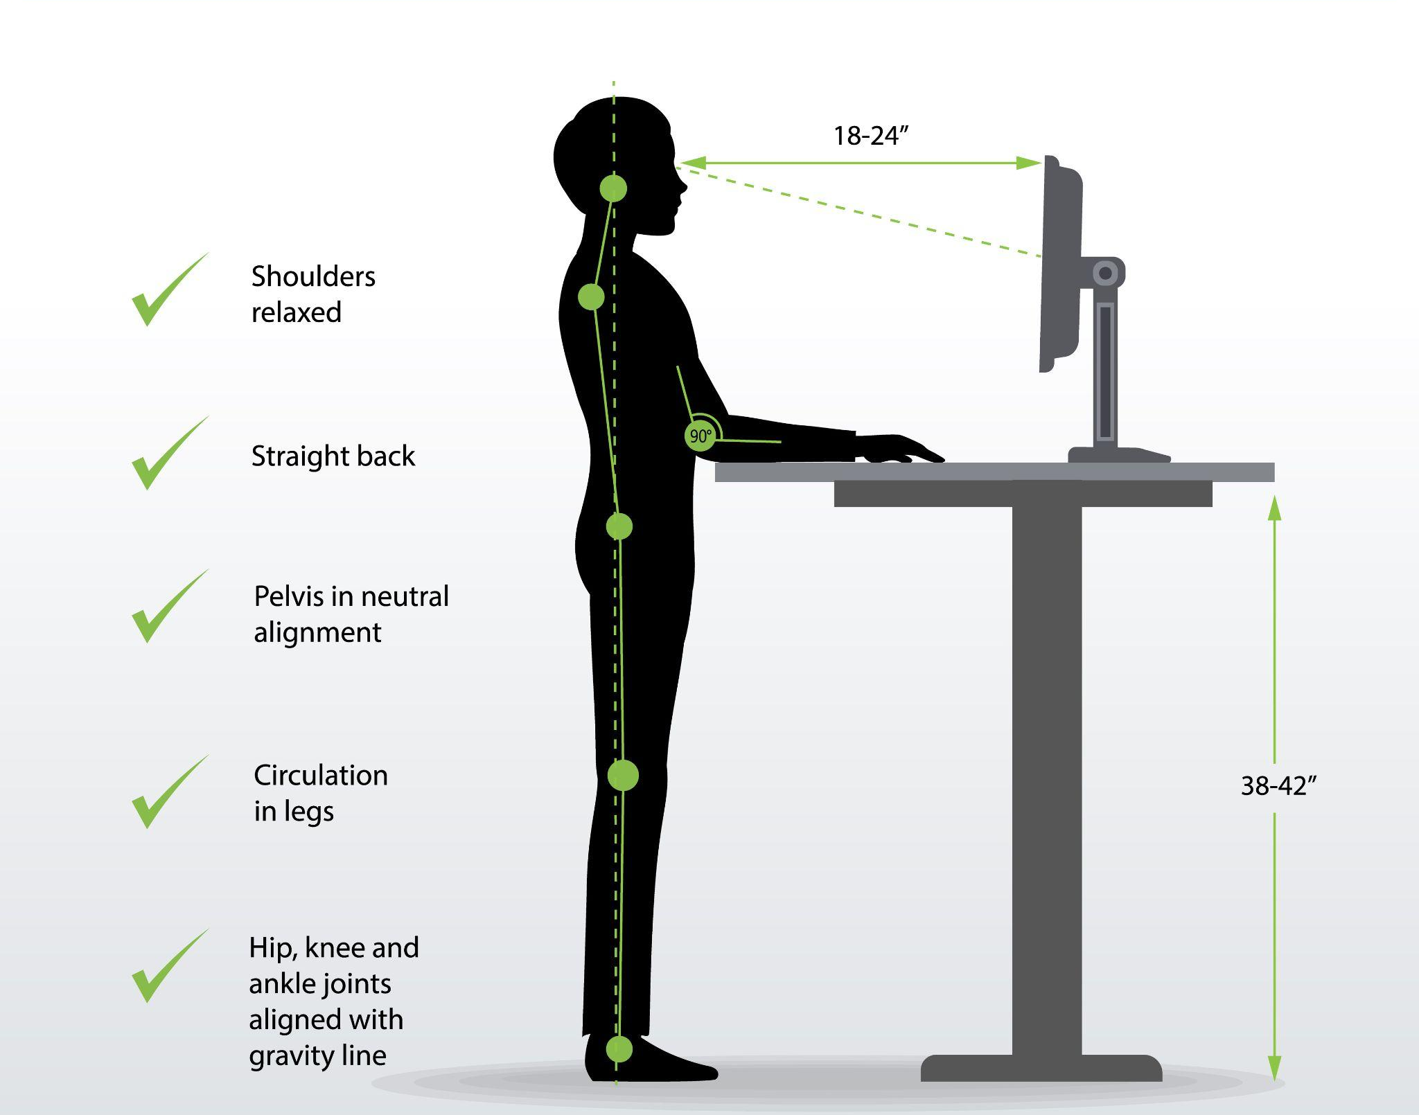

Keyboard and mouse position

- Sit or stand at least an arm's length away from your screen(s).
- Position your keyboard directly in front and centred with your body.
- Adjust the keyboard height so that your shoulders are relaxed, and your wrists are straight. When typing, wrists should not rest on a sharp edge (for example, the edge of your desk).
- Place the mouse pointer as close as possible to your keyboard.

Screens and lighting

- Adjust your computer screen(s) and monitor(s) so that your neck is in a neutral, relaxed position when you are working on your computer.
- Centre your screen directly in front of you, or above your keyboard.
- Ensure you have proper lighting. The brightness of your monitor should be similar to that of your surroundings. Adjust your screen brightness or use a desklamp if needed.
- Position your screen(s) so that you reduce any screen glares, and adjust curtains or blinds as needed to reduce glares.
- Give your eyes frequent short breaks from your screen by looking away from the screen, focusing your eyes elsewhere, or covering them momentarily.

Desk organization

- Keep items you use often within reach (0 - 12 inches away).
- Set up your telephone on your dominant side.
- Use a headset if you use your phone frequently or for long periods of time.
- Keep reference materials and other documents in line with your monitor to avoid excess rotation and movement.

